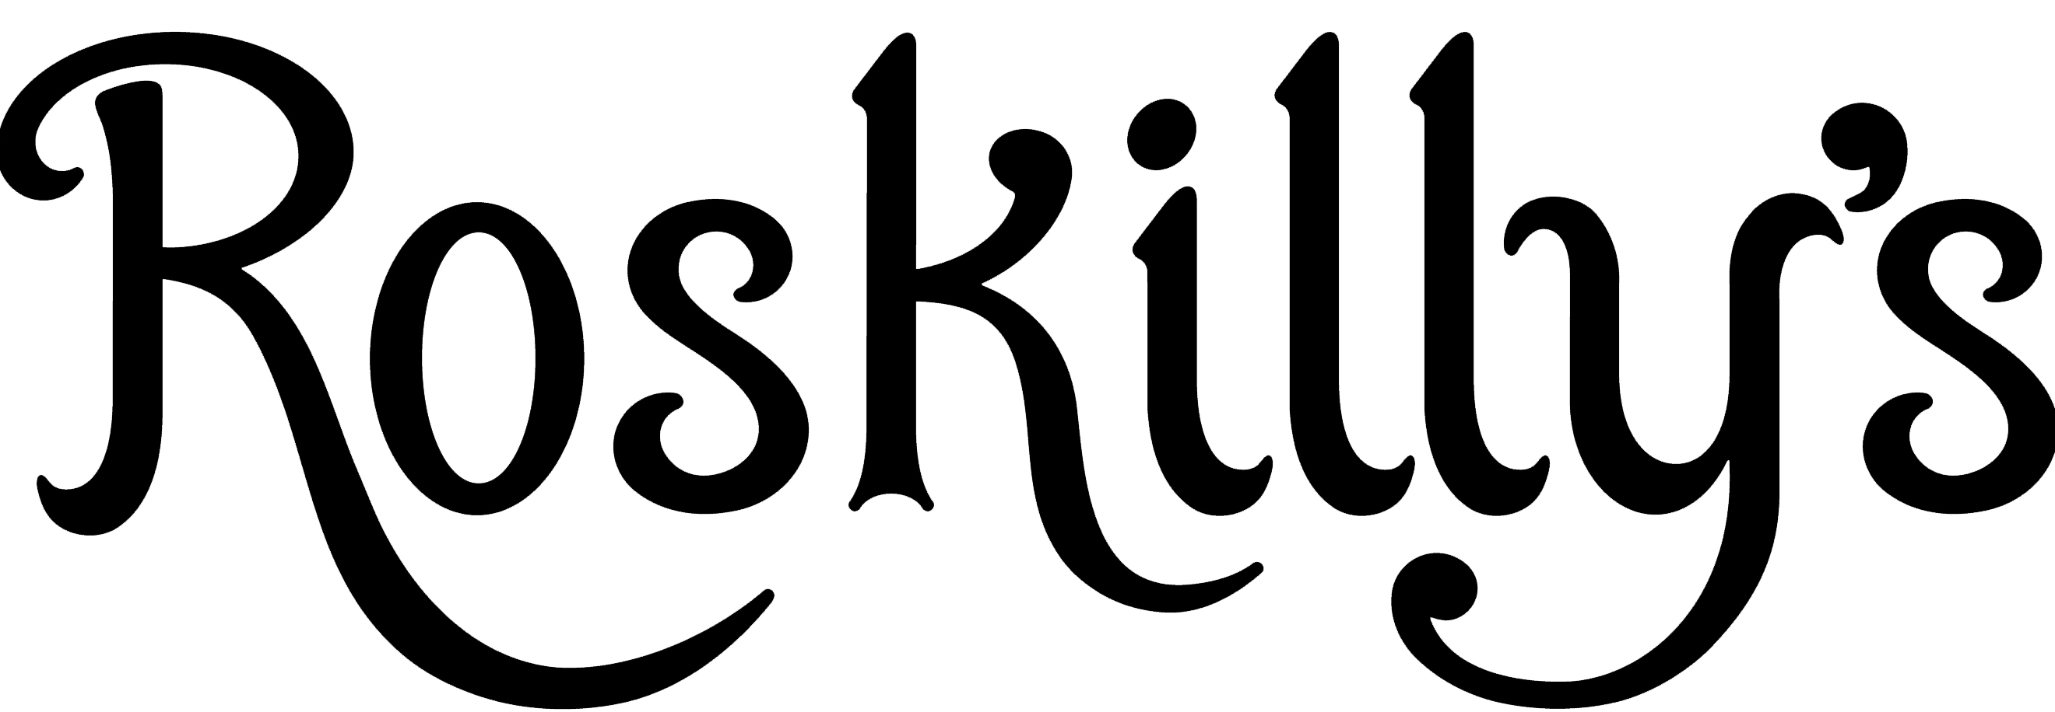
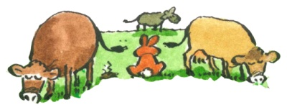

Breakfast served until 11.30am
Cornish breakfast, our own home reared pork sausage, smoked bacon, Hogs Pudding, grilled tomato, field mushroom, fried egg, baked beans, Roskilly’s marmalade & toast,
tea or coffee £8.50

Cornish Vegetarian breakfast, sautéd new potatoes, grilled tomato, field mushroom, two fried eggs, baked beans, Roskilly’s marmalade & toast, tea or coffee £7.50

Sausage or bacon Roll £4.95

Freshly baked Croissant with jam & butter £2.50

Toast and jam/marmalade £2

Kids Breakfast – rasher of bacon, sausage, egg and beans, toast & jam £5

Serving from 12 noon from the Wood Fires

Soup with home baked bread roll (please ask for details) £5.95

Salads
- Summer bean & salsa salad platter with home baked bread roll £10
- Warm roasted vegetables with wheat berries, barley, halloumi and walnuts £10
- Local crab salad with a lemon & dill mayonnaise and a fresh bread roll £12.50

Pie & Salad (served cold)

- Penny’s Cornish Blue cheese, plum & lentil Pie with spicy apricot chutney £10
- Penny’s Venison, chestnut & redcurrant jelly Pie with Cornish ale chutney £10
( some salads may contain nuts, please ask for details)

Pizza’s

- Three Cheese & onions (cheddar, mozzarella, Cornish Blue cheese) £8.50
- Roasted vegetables £8.50
- Tomato, cheese and fresh pesto £7.50
- Pepperoni £8.50
- Pulled Pork (please ask for extra chilli) £9
- Garlic bread £4.50

Burgers
- Roskilly’s home reared beef burger with dill pickled gherkin, our own tomato relish & beef tomato, coleslaw and chips £11
add cheese £ 1 add bacon £1 add pulled pork £1 add caramelised onion

- Moroccan spiced home reared lamb burger topped with yoghurt raita served with chips & fresh salsa £11.50

- Grilled vegetable stack - beef tomato, aubergine, courgette, field mushroom with blue cheese, halloumi & fresh pesto served in a brioche bun with chips & coleslaw £10

Hot n’ Spicy Pulled Pork Wrap (please ask for extra chilli) with sour cream, salsa & chips £12

Smoked Beef Sausages with chips, salsa and fiery, spicy beans £9

Sandwiches
Home baked fresh bread with a side salad
• Ham & cucumber with black pepper & whole grain mustard mayonnaise £7.50
• Cornish Yarg cheese & beef tomato, lettuce & gingery apple and almond chutney £7.50
• Local, handpicked white crab meat with a lemon & dill mayonnaise £10

Sides
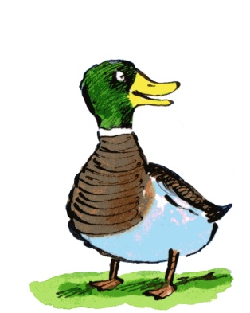
        - Garlic Bread £4.50
        - Portion of chips £3.50
        - Rosemary & thyme salted chips £3.75
        - Cheesy Chips £4.50
        - Bowl of Mixed salads £5
        - Focaccia, Olives, Olive Oil and Balsamic vinegar £5

Kids
- Fresh home baked bread & Butter £1.50
- Simple cheese or beans on toast £3
- Hot dog served with a side salad or chips £5
- Beef burger, home reared, served in a bun with chips & coleslaw £6.50
- Pasta with tomato sauce and topped with cheddar cheese £5
- Sausage & chips £5
- Soup and roll £5

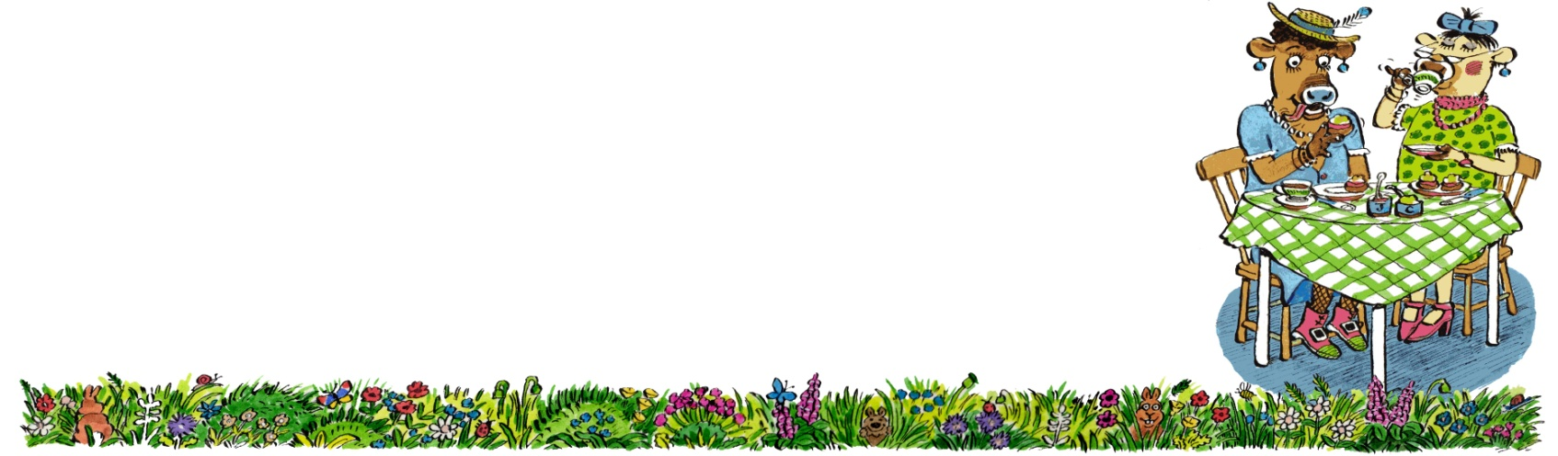
Cornish Cream Tea

A plain or fruit scone, Clotted Cream & strawberry jam served with
a pot of tea or a cup of coffee £4.50

Toasted tea cake & butter £2.95

